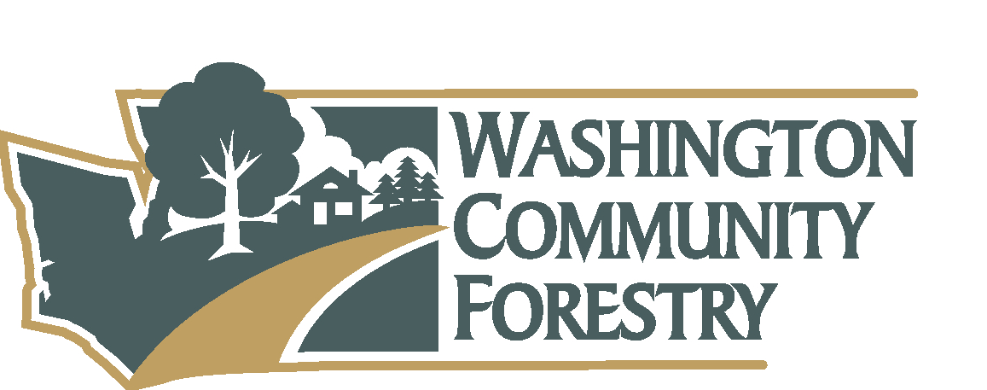
Washington Community Forestry Council Meeting
September 13, 2023
Conference Call- Zoom

Members Attending: Ben Thompson, Jess Stone, Semra Riddle, Jessi Bloom, Zandria Michaud, Lynn Suksdorf, Ian Gray, Tim Kohlhauff, Megan Dunn, Juli Hartwig, Joanna Martin, John Bornsworth
Members Absent: Solay, David, John, Julie, Jesse, Kathy, Stephen
Guests: Jen Watkins, Rachel Santa Olalla, Mike Sanborn, Andy Tate
Meeting Convened: 10:35 a.m.
Welcome: Call to order. Roll was taken. Chair welcomed members and guests, new members and participants introduced themselves. Previous meeting minutes are to be voted on at the next meeting due to discrepancy issues. This meeting is recorded for assurance of note taking and due the high interest of topics on the agenda.
Agenda Approved: Motion to approve agenda. Jess Stone moved and Ian Gray seconded motion. Unanimous approval.
Introduction to new DNR UCF staff Rachel Santa Olalla (Outreach Specialist) and Mike Sanborn (Urban Forestry Technician for eastern WA).
Federal Legislative and Budget Update (IRA Funding) Stephen Baker USFS
Stephen couldn’t join the meeting. Jen shares that Stephen verbally awarded DNR one of two grant requests DNR applied for. There are $5M in funds that would go to communities. The IRA funds DNR applied for would give Urban Forestry $8M to put towards workforce development, education and outreach, and would complement other DNR grant opportunities. DNR has not heard an update on this request thus far.
Ben shares other updates:
Ben shares updates on annual reporting using the tree board. He shares about the DNR Forest Health Tracker which keeps track of landscape treatments across the state provided by DNR. (For example, include reducing ladder fuels is a treatment.) Urban Forestry fits into the Forest Health Tracker but technical assistance haven’t been recorded or analyzed. New funding would allow capacity for technical assistance and other treatments to be clearly tracked across the state.
Ben also shares updates about UCF using Salesforce. Modifications are being identified to keep track of constituent outreach and technical assistance, including their outcomes. Salesforce will be used to track engagements in a meaningful way. Some items (ie: CARs data) won’t be able to be tracked using Salesforce and other systems will be sought out to track those data.
Ben addresses the issue of dense housing mandates and their implications on urban forestry. While densifying, it is important to make sure there is also tree equity. He suggests interagency coordination in the UCF Strategic Plan. It’s important for WCFC to be part of the decision-making process when groups like Dept of Commerce or others are making laws and legislation about housing density. Semra shares that these projects often strip the land of existing trees and vegetation when constructing and leave only grass behind after the housing is built. Megan adds that it is possible to build dense housing and plant enough trees, that the decision is not one or the other.
15 Minute Break for council (reconvene at 11:35am)

WA DNR UCF Strategic Plan
Ben shares goals and objectives of the UCF Strategic Plan and welcomes comments from the Council:
Objective 1.1 - DOE has purchased high-resolution land cover data, and it now needs to be analyzed on a community-by-community basis.
Objective 1.2 - Tree Stock supply chain issues. Measures of success: all trees planted through the program funding are to be tracked and inventoried.
Objective 2.1 - (A-E) are all things that are already being done.
Lynn questioned whether cities have owned this objective or if there is resistance to it.
RCW 76.15.100 is put into the grants – 50% of funding goes to highly impacted communities.
Break for council (lunch- reconvene at 12:30 pm)
Comments on objective 3.2 - There is no baseline for maintenance. The difference between basic maintenance and deferred maintenance is not currently defined.
Comments on objective 3.3 - Concerns were raised around FTEs available to help deliver DNR programs, tech assistance, etc. Ben assures that new hires will be filling those roles.
Comments on objective 3.4 - Workforce Development, Youth Conservation Corps Crews
Comments on objective 4.1 - This is made possible with high-resolution aerial data and LiDAR
Can the measure of effectiveness also include the funding to where disparities are higher?
Is there a way to include Tree Canopy in the Environmental Health Disparities Map?
Now that we have that data, we can request the map be updated. This map is not made public yet. DOE had collected this data.
Comments on objective 5.1 - there is an appreciation for the innovation and risk-taking.
Comments on objective 5.2 - The program may expand to include a scientist.
Comments on objective 5.3 (A)
Ian Comments: Model tree ordinances are too generic for use.
Concerns around the population number deciding the amount of assistance.
5 Minute Break for council (reconvene at 1:30 pm)
UCF Program Update (1:50)
Ben reviews new hires and new positions that are open for hire. The program now has 8 staff including a Contracts Coordinator that works solely on UCF contracts and a GIS Specialist that is hired by the UCF program to work on UCF work products. The program is still hiring 3 new positions: Financial Assistance Planner, Urban Forestry Specialist, and Tree Equity Planner. He explains that having structures and systems are required as the team grows and live all over the state.
The Evergreen Communities program is coming along and the team is looking for a fall launch of the program with anticipation for more widespread participation in 2024. The Steering Committee will test this for us in 2023 and provide feedback while we finalize the program for its roll out in 2024.
The 2024 CFA Grants and explains the reasoning behind the series: DNR needs quality applications. He also explains how the release of the Direct Prioritization Map coincides with the opening of the Grant Cycle.
Ben Thompson provides an update on hiring, Tree Equity, Evergreen Communities, Inventory work, Program Prioritization, Direct Investments, Grants, etc.
Jess considers the Strategic Plan and considers youth in green jobs, and wonders where there can be training opportunities or hiring opportunities.
Andy shares that DNR has policy for workforce development and youth education, but currently there are no training programs. IE: WCC crew style of work with DNR. This is a common question, and the agency has noted this is important to people.
Ben continues to share data entry from Daria, Zach, and Drew. Tree Inventory points are being added to UF map. Zach and Daria are doing extra tree inventory in addition to the UFIA project. Once there is more UFIA collection, it will be clear what staff capacity is for tree inventory.
The Statewide Prioritization map is shared with the WCFC members. Ben explains that map’s inputs while showing the draft version of the map:
- Salmon buffer
- Salmon buffer impaired
- CARS data (Community Accomplishment Reporting System)
- Health disparities score
- Canopy Cover %
- Impervious area %
2023 WCFC Meeting Dates
February 8, 2023 – annual meeting (Completed)
April 18, 2023 – (Completed)
June 7, 2023 – (Completed)
September 13, 2023 - (Completed)
November 1, 2023
Adjourn: 2:04 PM
Next Meeting: November 1, 2023. Via Zoom.

Zoom meeting chat:
Semra Riddle 10:45 AM
Reminder that Chat is likely also recorded into the record - even direct messages to other attendees.

Lynn Suksdorf, PhD 10:47 AM
Welcome Rachel and Michael.

Michael Sanborn 10:47 AM
Doing fine Ben!
Snohomish County Council, Megan Dunn (she/her) joined as a guest

Rachel Santa Olalla, DNR UCF Outreach Specialist 10:50 AM
Thank you, Lynn.
Joanna Martin joined as a guest
Jessi Bloom left
Jessi Bloom joined as a guest

Jen Watkins 10:57 AM
For reference here is the grant application packet that DNR provided to US Forest Service for the non-competitive IRA funding for Urban and Community Forestry: https://deptofnaturalresources.box.com/s/iudmuv6vncujl4ie7xwq6pguig7pzp5t
Andy Tate joined as a guest

Jen Watkins 11:04 AM
Apologies for the slow technology on my end, here is the link to the proposal we submitted for the competitive IRA funding focused on urban forestry education and training in WA: https://deptofnaturalresources.box.com/s/iudmuv6vncujl4ie7xwq6pguig7pzp5t
Oops, correction to 2nd link: https://deptofnaturalresources.box.com/s/5ncpu1klu48jmj5twzzs7ny29szzlh51

Ian Gray - Municipal Forestry representative 11:16 AM
I am going to have to step away from my desk for a bit - i'll try to jump back on later

You to Semra Riddle (Direct Message) 11:20 AM
Maybe we can break after this part of the discussion and dig into the goals after the break?

You to Andy Tate (Direct Message) 11:23 AM
This is what I want to use the 150K from Climate funds to investigate

Andy Tate to You (Direct Message) 11:23 AM
Yeah, feel free to bring that up if helpful.

Megan Dunn, Snohomish County Councilmember (she/her) 11:24 AM
Sound like Rep Davina Duer?

You 11:27 AM
We do have grants for that!
Jessi Bloom left
Michael Sanborn left
Michael Sanborn joined as a guest

Lynn Suksdorf, PhD 11:35 AM
I am back.
Jessi Bloom joined as a guest

Andy Tate to You (Direct Message) 11:37 AM
Has this been sent out yet or will you be doing that after?

Jess Stone, Pierce County Parks 11:44 AM
We are currently trying to do just that, lots of challenges, but we are struggling to get tree stock through commercial sources.

Jess Stone, Pierce County Parks 11:45 AM
The dream I'm trying to do is build a tree nursery at our waste water treatment plant using treated water. We have the space (and the fertilizer).

Jess Stone, Pierce County Parks 11:50 AM
Lynn, do you have a question?
Semra Riddle left
John Bornsworth (Peninsula Environmental) joined as a guest
Semra joined as a guest
Jen Watkins left

John Bornsworth (Peninsula Environmental) 12:00 PM
I apologize for my tardiness!
Semra left
Semra Riddle joined as a guest
Jessi Bloom left
Semra Riddle left
Semra Riddle joined as a guest

Lynn Suksdorf, PhD 12:29 PM
I am back.
Jessi Bloom joined as a guest

Jess Stone, Pierce County Parks 12:32 PM
Ah yes, for incorporated areas only.

Tim Kohlhauff 12:32 PM
Glad to see assistance for maintenance!

Andy Tate 12:41 PM
That also shows how the goals can complement each other - goal 2 directs us to work more closely with those communities which would then have an increase in the measures of goal 3. That type of feedback is something we can specifically identify in the accompanying action plan about those 5/10% communities and how/where they are targeted.

Jess Stone, Pierce County Parks 12:45 PM
Would this be through NYC (northwest youth corps)?

Andy Tate to You (Direct Message) 12:59 PM
Scroll down a bit to the rest of the measures

You to Andy Tate (Direct Message) 1:08 PM
Are we ready to share a copy of the strategic plan with the council? Someone is bound to ask

Lynn Suksdorf, PhD 1:09 PM
Good comments, Ian.

Zandria Michaud, City of Kent Councilmember 1:11 PM
yes, municipalities definitely have capacity and financial restraints right now.

Andy Tate to You (Direct Message) 1:12 PM
Absolutely. I got the final wrapped up last week to be ready and that should be what you are looking at. Emailed Friday at 9:16am, if not.
Michael Sanborn left

Lynn Suksdorf, PhD to You (Direct Message) 1:19 PM
Ben, I saw that other council members participate in the Equity meeting for other positions, but if you would like another it is a subject I am very interested in if you have a need.

You to Andy Tate (Direct Message) 1:20 PM
I think that is the email I pulled the screen-shared version from

You to Andy Tate (Direct Message) 1:27 PM
I Want to screen share the prioritization with them, okay? I will leave that until I hear back from you.

Andy Tate to You (Direct Message) 1:27 PM
Yeah

You to Andy Tate (Direct Message) 1:27 PM
cool thx

Andy Tate to You (Direct Message) 1:27 PM
There might be some good feedback to incorporate.

Lynn Suksdorf, PhD 1:43 PM
Jess, it would be great if there was a job and/or internship board to post positions in one place for all green-job positions to. If all of the related state stakeholders or related industries could post positions to would be an amazing resource. But hat may be too challenging to get up and running, let alone keeping current.

You 1:52 PM
https://dnrtreelink.wordpress.com/2023/07/12/dnr-offers-grant-webinars-to-assist-applicants-in-2024-grant-cycle/

