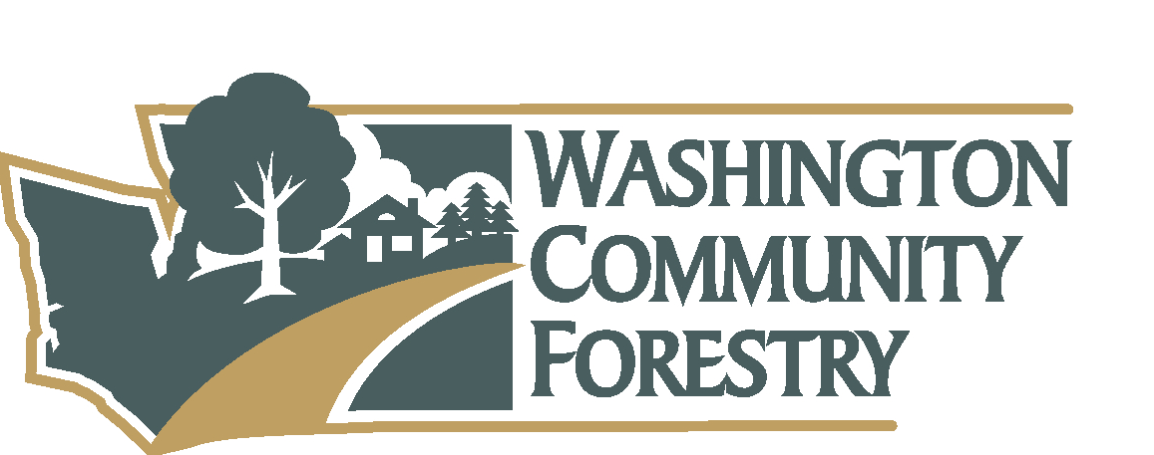
Washington Community Forestry Council Meeting
April 18, 2023
Conference Call- Zoom

Members Attending: Margaret Brost Tim Kohlhauff, Zandria Michaud, Ian Gray, Semra Riddle, Jess Stone, John Bornsworth, Megan Dunn, Juli Hartwig
Members Absent: Solay, Lynn, David, John, Julie, Jesse, Kathy, Stephen
Guests: Julia Kast, Zach Mellema, Terra Rentz, Andy Tate, Em Roberts, Stephen Baker, Daria Gosztyla
Meeting Convened: 10:44 a.m.
Welcome: Call to order. Roll was taken. Chair welcomed members and guests, new members and participants introduced themselves. Jen Watkins announced as new Forest Resilience Division Manager. Review of agenda. Previous meeting minutes to be reviewed during lunch break.
Agenda Approved: Motion to approve agenda. Jess Stone moved and Ian Gray seconded motion. Unanimous approval.
Urban Forestry Strategic Plan: Information and Questions
Terra Rentz, Strategic Advisor of Forest Resilience Division introduced strategic planning process and status update. Planning process came from HB 1216. Program was previously 100% federally funded program, now DNR’s UCF program has multiple funding sources. Opportunity to revisit past strategic plans and reflect on what UCF’s role is to move forward cohesively. Roadmap for work with trackable and measurable action items that can be used on day-to-day basis. It is a 6-year strategic plan of July 2023- Jun 2029 (based on state fiscal year July 1st -June 30th) will align with future financial cycles. Goals
Request to access to outline. Terra will have document to share minimum 2 weeks prior to June 2023 meeting. Opportunity for group to formally vote and provide feedback.
Terra displayed short preview, including purpose, vision, mission, and values component with five primary goals overview. Notes and comments on overview below.
Purpose Statement: present in previous strategic plan.
Vision: Ian provided copy edit. Semra asked where this document will align us within state in context of housing crisis and upcoming legislation. Terra spoke about where DNR’s role and expertise aligns.
Mission, Overarching Strategy, Core Values: reviewed, no questions from council.
Goals/Objectives:
Goal 1: Jess Stone asked about seed/tree stock and websters nursery and connecting distributers.
Goal 2: No questions from Council.
Goal 3: John asked where we currently stand with data for baseline of objectives. Many of the strategies immediately address finding baseline for objectives.
Goal 4: No questions from Council.
Goal 5: No questions from Council.
5 Minute Break for council (reconvene at 11:36am)

UCF Program Update
Program update provided from Ben Thompson, DNR UCF Program Manager.
Julia Kast has completed Tree City USA, Tree Campus: Higher Ed and Tree Line USA reviews and is now moving onto Evergreen Communities planning.
State Arbor Day celebration on 4/12 held on Capitol Campus. Semra provided recap. Brief speeches from Governor, Commissioner and DES. Event was met with protestors. Song and Poem from children of state childcare center followed by gifts presented to Governor from each class. Em Roberts created Arbor Day tree plantings map on Capitol Campus available online.
Daria Gosztyla and Zach Mellema working with communities to collect inventory data. They attended training and received Urban FIA certifications. Inventory data collection will begin in spring 2024.
Em Roberts, Western WA Technician. Uptick in requests for technical assistance.
Team vacancies- Outreach Specialist, Urban Forestry Specialist, Eastern WA Technician will be posted within next few weeks. Fourth position being created to facilitate grants from start to finish and grant related support still being edited and reviewed.
Financial Assistance- agency is taking notice of need for separate and formalized grant process to ease burdens of partners.
MOU between DNR and American Forests released. American Forests is bringing expertise in tree equity mapping and providing broader base of tools to provide to support communities in making informed decisions. Seattle event with Commissioner announcing MOU on 4/13 included Mayor of Seattle being the first to sign on to “tree equity collaborative”. American Forests will have staff person to lead committee.
2023 Grant Application Review: $350,000 funding to be released with over $1 million in requests from 30 applicants. Possibility of additional funding.
State Budget
Break for council (lunch- reconvene at 12:34pm)- council to review previous meeting minutes during break.
Minutes Approved: Motion to approve agenda. Tim Kohlhauff moved and Jess Stone seconded motion. Unanimous approval.
IRA Funding Brief; DNR Proposal
Ben Thompson is joined by Stephan Baker with US Forest Service. Congress passed IRA funding for $1.5 billion over next 10 years. US Forest Service giving funding for a 5-year interval. States given first opportunity to apply for funding with$250 million available to the states in first round. DNR submitted proposal for $47 million. Ben explained overview of DNR’s proposal. DNR was awarded $6 million. See below chat for breakdown of funding per region.
USFS released notice of funding opportunity (NOFO)- now open to states and everyone else who is eligible for UCF grants. Minimum request of $100,000 with maximum request of $50 million. Applications are due June 1st, 2023.
UCF webinar on May 3rd 10-11 am to discuss what DNR plans to do with already awarded $6 million and hear an orientation on IRA funding opportunity.
Office hours to meet with Ben to ask IRA grant related question held on: May 10th, May 17th, May 26th, May 31st from 10am-12pm. Email Julia.Kast@dnr.wa.gov for calendar invite link.
Stephan shared there are concerns nationally about state capacity. USFS trying to be careful and deliberate about allocations.
Andy shared that DNR is still deciding on prioritization of awarded funding.
Questions and clarification asked from Ian Gray, Megan Dunn and Jess Stone. Continued discussion on how disadvantaged communities are not going to be as competitive with quick turnaround and federal application process.
Ben inquired if WA DNR should apply for additional funding. Board members expressed support of applying for additional funds.
5 Minute Break for council (reconvene at 1:35 pm)
Debrief from Partners Conference
Semra led discussion on Partners Conference in November 2022. Agenda website linked in chat records. Semra learned a lot about policy
Positives:
- Access to resources: links to tree lists, resilient trees
- Large turnout of participants – more than 750 attendees
- Trees were finally “having their moment”
- Private moment with Commissioner, scholarship recipients, DNR UCF team (Ian was able connect with 300 trees Bellevue which led to tree giveaway donation)

Could improve:
- Some presentations/information was not “groundbreaking” to attendees
- Loss of momentum post event: Ian G. story on tree removal of 51 street trees including landmark trees. Daily reality: it is difficult for green infrastructure advocates.
Stand out learning:
- Lidar street tree scanning vehicle tool (Semra & John B)
Discussion of June WCFC Meeting
June 7th, 2023 slated for next meeting. In-person meeting with hybrid options in Olympia/Seattle Metro Area. Semra and Jess to start agenda. Ben to send out invitation to Commissioner to attend.
2023 WCFC Meeting Dates
February 8, 2023 – annual meeting (completed)
April 18, 2023 – (current)
June 7, 2023 – possible in person meeting
September 13, 2023
November 1, 2023
Adjourn: 2:04 PM
Next Meeting: June 7, 2023. In person, time and location to be determined.
Zoom meeting chat:
Tim Kohlhauff 10:42 AM
Congratulations and welcome Zandria!
Zandria Michaud, City of Kent Councilmember to Everyone 10:44 AM
Thank you!
Zach Mellema-DNR to Everyone 10:46 AM
Hi All, In a loud coffee shop just listening in. I'm Zach Mellema and work for the DNR UFC Forest Inventory.
Jess Stone, Pierce County Parks to Everyone 10:48 AM
OK Tim, whats $5 for 5?
John Bornsworth (Peninsula Environmental) to Everyone 10:48 AM
I had the same question!
Margaret to Everyone 11:13 AM
Love the structured approach
Tim Kohlhauff to Everyone 10:53 AM
So sorry, I should have changed the background for this meeting. WSU is trying to raise money to fund an Endowed Chair for the Master Gardener program. The background refers to a request for $5.00 month for 5 years from potential donors
Jess Stone, Pierce County Parks 11:38 AM
Hope the campain was a success! Though deep down I was hoping for 5 trees for $5.
Tim Kohlhauff 11:39 AM
I like that idea better!
Semra Riddle to Everyone 11:39 AM
My apologies, my dog needed a treat.
DNR Urban & Community Forestry to Everyone 11:53 AM
Drew and I ran the numbers yesterday, 97 WA cities are presently represented in the Tree Equity Map. We are figuring out which are missing.
Tim Kohlhauff to Everyone 12:43 PM
WSU Office of Research Support & Operations (ORSO)
Andy Tate to Everyone 12:46 PM
FS Region
Eastern Region $99,075,000
Southern Region $65,850,000
Pacific Southwest Region $46,950,000
Rocky Mountain Region $10,725,000
Pacific Northwest Region $9,750,000
Southwestern Region $7,875,000
Intermountain Region $3,750,000
International Institute of Tropical Forestry $3,000,000
Northern Region $2,250,000
Alaska Region $750,000
Grand Total $249,975,000
DNR Urban & Community Forestry to Everyone 12:48 PM
https://dnrtreelink.wordpress.com/2023/04/07/update-on-historic-ira-funding-opportunity-for-urban-and-community-forestry/
Stephen Baker to Everyone 12:50 PM
Information on national Notice of Funding Opportunity: https://www.fs.usda.gov/managing-land/urban-forests (deadline to apply: June 1)
Jess Stone, Pierce County Parks to Everyone 12:50 PM
Can you post office hours in chat?
You to Everyone 12:51 PM
May 10th, May 17th, May 26th, May 31st from 10am-12pm
DNR Urban & Community Forestry to Everyone 12:55 PM
Just updated the Tree Link to include the dates for office hours as well.
DNR Urban & Community Forestry to Everyone 12:55 PM
(we set those up late yesterday)
Ben Thompson, DNR Urban Forestry Program Manager to Everyone 12:57 PM
I just forwarded an email that went out yesterday with the information about our webinar and the office hours we are offering.
DNR Urban & Community Forestry to Everyone 1:02 PM
Do equipment rentals or leases qualify? That's something I'm currently trying to glean from the RFA.
Andy Tate to Everyone 1:05 PM
This would use the federal definition of equipment which is typically a cost of more than $5,000 and a life of more than 1 year so rentals fall under supplies or contractual depending on how it is integrated into the narrative. https://www.ecfr.gov/current/title-2/subtitle-A/chapter-II/part-200/subpart-A/subject-group-ECFR2a6a0087862fd2c/section-200.1
Jess Stone, Pierce County Parks to Everyone 1:11 PM
Ben and Stephen, appreciate your support and guidance and stepping up to assist in navigating us through this.
Andy Tate to Everyone 1:24 PM
Only if that state funding hasn't already been used as match.
Semra Riddle to Everyone 1:35 PM
https://www.arborday.org/programs/pcf/agenda.cfm
Ben Thompson, DNR Urban Forestry Program Manager to Everyone 1:41 PM
Here is the Trees for Resilience Toolkit that Ian referenced: https://betterground.org/about-toolkit/
Jess Stone, Pierce County Parks to Everyone 1:54 PM
Rumor has it that Ben will bring doughnuts.
Jess Stone, Pierce County Parks to Everyone 1:57 PM
I can also volunteer our facilities near I-5 (Lakewood/Spanaway/Tacoma area)
Its Parks, In addition to meetings we can also do birthday parties and weddings.
Juli Hartwig (WSDOT) 2:02 PM
That's really cool!

