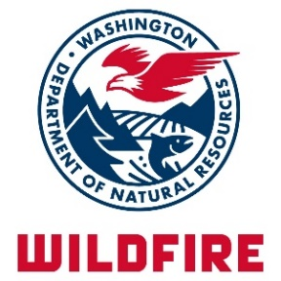
DEPARTMENT OF
NATURAL RESOURCES
WILDFIRE DIVISION
1111 WASHINGTON ST SE
P.O. BOX 47037
OLYMPIA WA 98504-7037
360-902-1300
WWW.DNR.WA.GOV

Radio Communication/Wildfire Risk Reduction

2018 Grant Application

Purpose of the grants:
This 2017 Washington State Legislature appropriation is solely for chapter 280, Laws of 2017 to support local capacity for wildfire suppression in any county located east of the crest of the Cascade mountain range that shares a common border with Canada and has a population of one hundred thousand or less. Funding is available for communication equipment and wildfire risk reduction activities prioritized to fire departments, fire districts, emergency management services and regional fire protection service authorities in these counties that:
- serve a disproportionately higher percentage of low-income residents as defined in RCW 84.36.042, and
- are located in areas of higher wildfire risk, and
- have a shortage of reliable equipment and resource.

Application Directions
- Fill out application completely. Incomplete applications will not be accepted.
- Signed applications must be received no later than close of business (COB) on 5/4/2018.
- Applicants may only submit one application.
- Maximum funds distributed will not exceed $140,000. Funds will be available to qualifying counties.
- Submit completed and signed application by one of the following methods:
  - Email: DNRREWDRCWRRgrant@dnr.wa.gov
  - Mail: Wildfire Division
ATTN: 2018 RCWRR Grant Applications
Washington State Department of Natural Resources
1111 Washington Street SE
Olympia, WA 98504

Contact Information

- Applicant: County Agency, (Full Name)

- Mailing Address:
Street City Zip Code

County Contact Email

- Contact Name:
Printed Name Phone
(XXX-XXX-XXXX)

Title

Eligibility Information

- Applicant is a:

Fire Department

Fire District

Regional Fire Protection Service Authority

Emergency Management Service

Other (Specify)

- List the rural communities and/or areas the project will serve. Priority will be given to communities/areas that have a disproportionately higher percentage of low-income residents and areas of higher wildfire risk (enter names in table below):

Rural Community/Area Name | Rural Community/Area Name

- Funding Request

Provide the following information for the project:

- Project Category – check only one box

Radio Communication Equipment

Wildfire Risk Reduction Education and Outreach

Wildfire Risk Reduction Technical Assistance

Wildfire Risk Reduction Fuel Mitigation

Other Wildfire Risk Reduction
Describe:

- Provide a narrative describing the project, project timeline, and how the project strengthens the local capacity for controlling risk to life and property that may result from wildfires. Describe how this project addresses applicant shortages of reliable equipment and resources.

- Complete the “Project – Fund Request Summary” detailing required purchases required to complete the project.

Project - Fund Request Summary
2018 RCWRR Grant
List all equipment, material, labor, etc. required to complete the project. | Funds Requested
Applicable Sales Tax (if not included above)
Total

Signature Block

I certify that:
- The information provided is true and accurate to the best of my knowledge
- If awarded a grant, applicant will comply with the following:
- Complete approved project(s) no later than June 1, 2020.
- Provide DNR with photos of completed project(s).
- Provide DNR with supporting documentation of all costs paid for with grant funding within 30 days of project completion or June 15, 2020, whichever is earlier.
- Return all unused grant funds to DNR within 30 days of project completion or June 15, 2020, whichever is earlier.
- Maintain fiscal records pertaining to the grant award for seven years after project completion or any dispute resolution, whichever is later.
- Comply with all state and federal laws, rules and regulations.
- DNR reserves the right to waive the requirement of project photos submittal.

Agency Authorized Representative

Printed Name Title

Signature Date

Maps for Project Area Selection

The following pages contain a map of each county eligible for this grant. Within each map, the respective County’s census block group polygons are displayed and numerically-labeled. This web map link is provided for more location detail if needed:

http://arcg.is/1WOqSe

Please use the check boxes to identify the project location(s) on the map. Multiple boxes/counties may be identified.

Okanogan County – Census Block Groups
Please use the check boxes to identify the project location(s) on the map. Multiple boxes/counties may be identified.

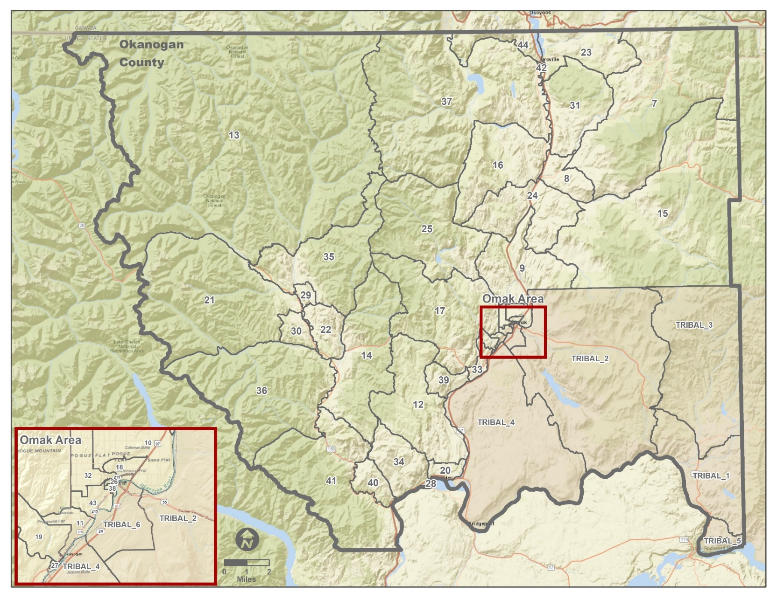

7 | 12 | 17 | 22 | 27 | 32 | 37 | 42 | TRIBAL_3
8 | 13 | 18 | 23 | 28 | 33 | 38 | 43 | TRIBAL_4
9 | 14 | 19 | 24 | 29 | 34 | 39 | 44 | TRIBAL_5
10 | 15 | 20 | 25 | 30 | 35 | 40 | TRIBAL_1 | TRIBAL_6
11 | 16 | 21 | 26 | 31 | 36 | 41 | TRIBAL_2
Ferry County – Census Block Groups
Please use the check boxes to identify the project location(s) on the map. Multiple boxes/counties may be identified.
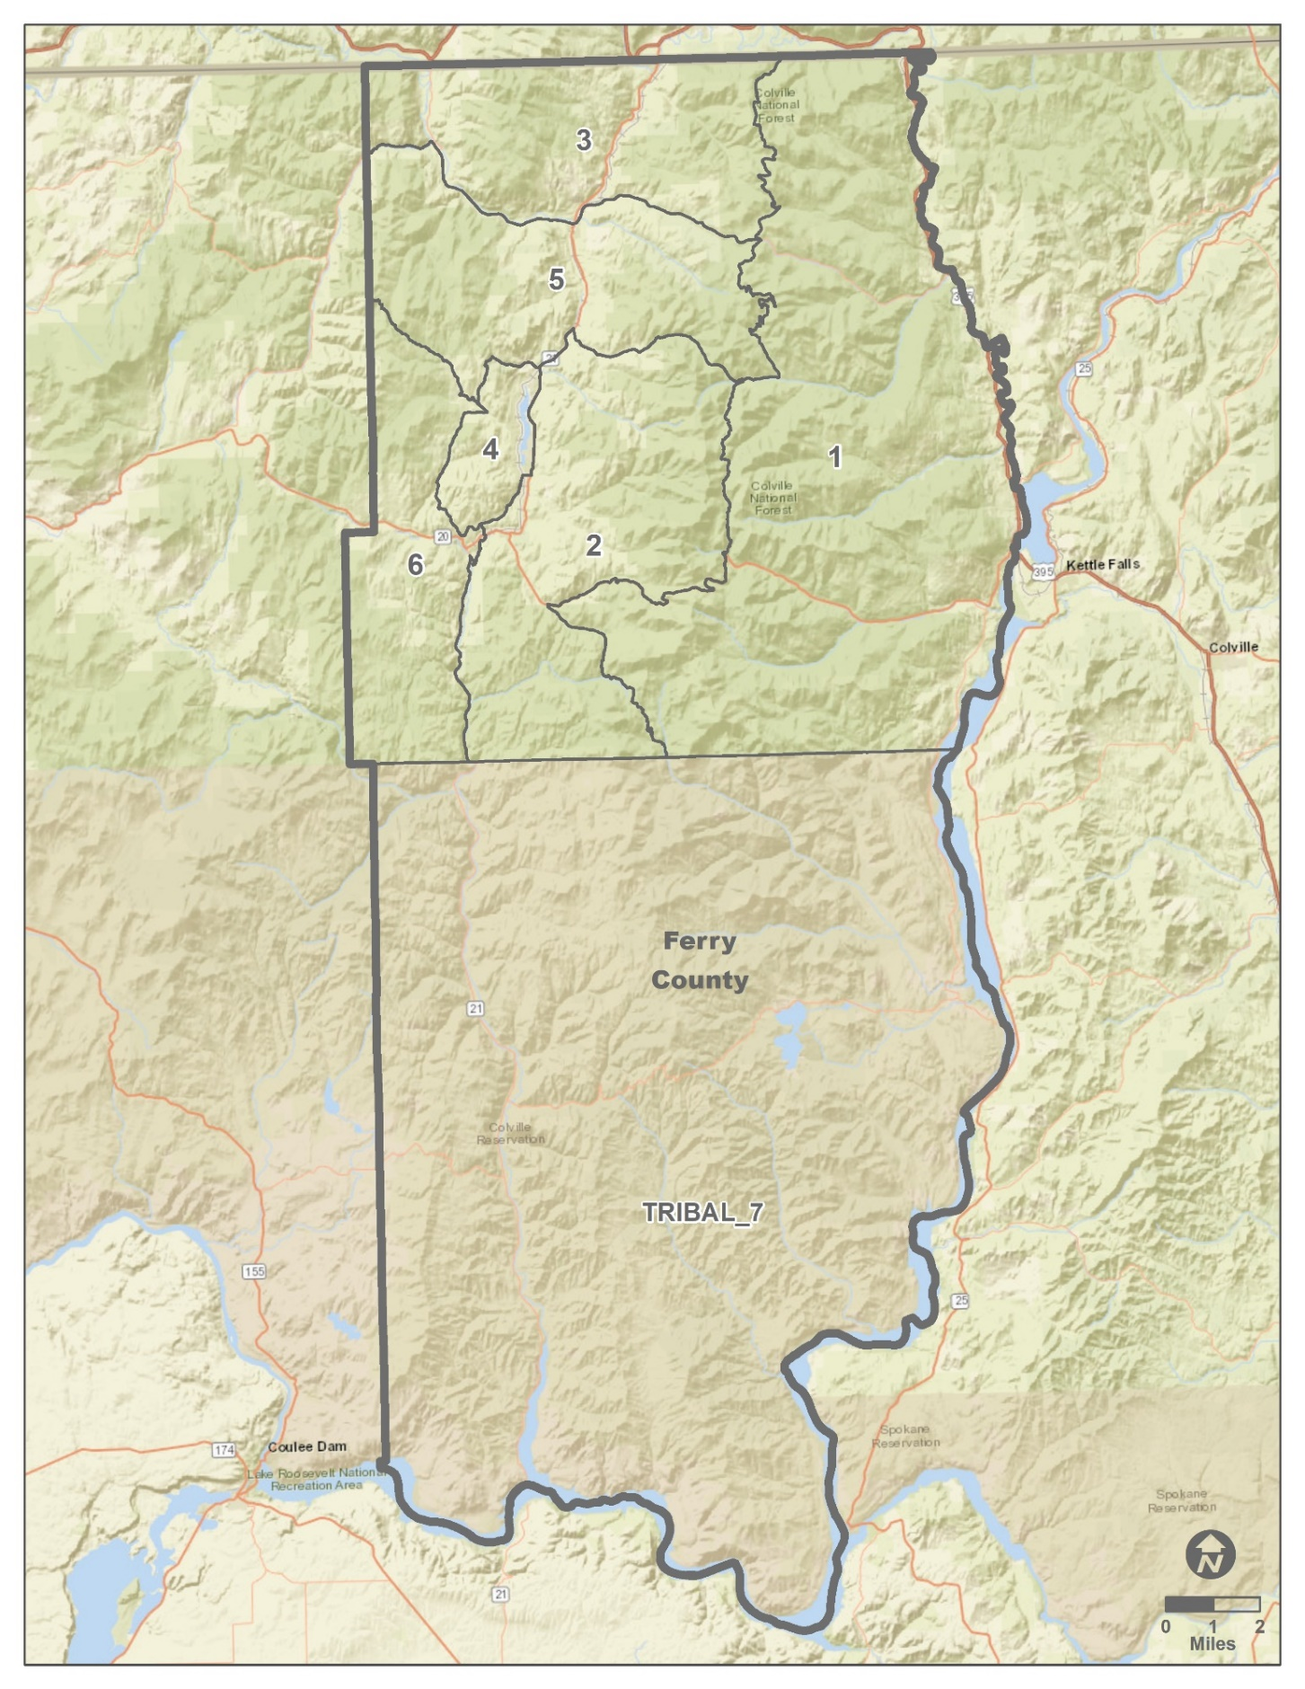

1 | 2 | 3 | 4 | 5 | 6 | TRIBAL_7
Stevens County – Census Block Groups
Please use the check boxes to identify the project location(s) on the map. Multiple boxes/counties may be identified.
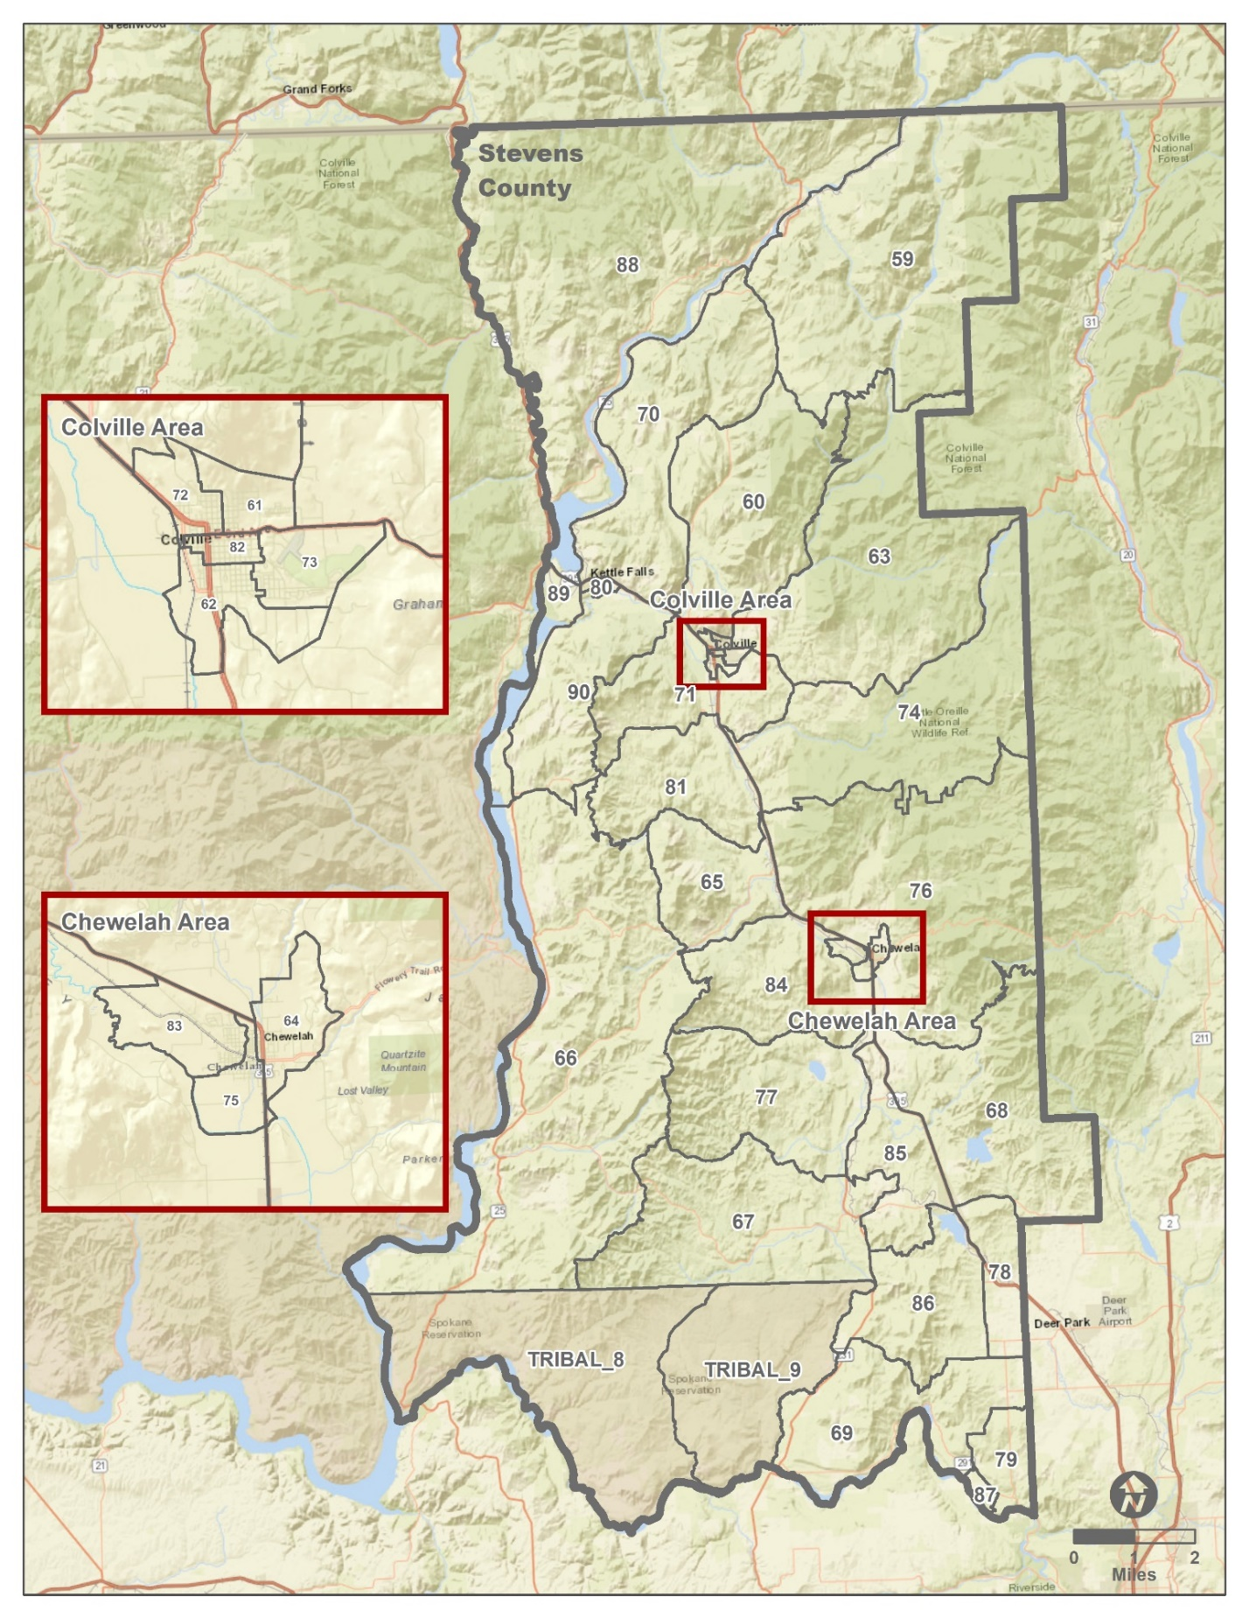

59 | 63 | 67 | 71 | 75 | 79 | 83 | 87 | TRIBAL_8
60 | 64 | 68 | 72 | 76 | 80 | 84 | 88 | TRIBAL_9
61 | 65 | 69 | 73 | 77 | 81 | 85 | 89
62 | 66 | 70 | 74 | 78 | 82 | 86 | 90
Pend Oreille County – Census Block Groups
Please use the check boxes to identify the project location(s) on the map. Multiple boxes/counties may be identified.
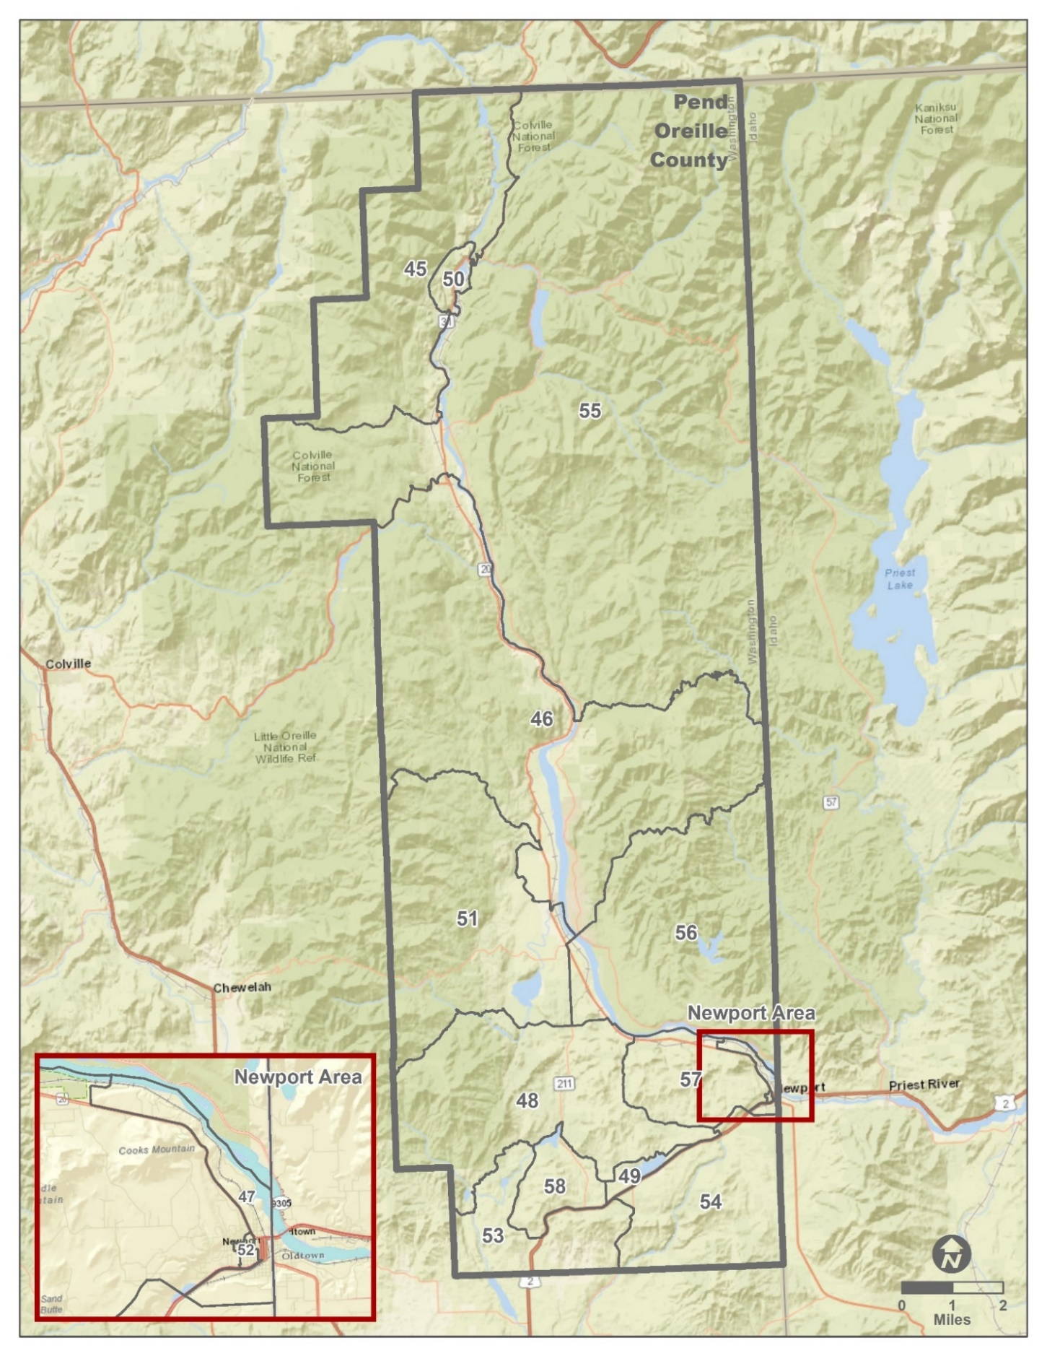

45 | 47 | 49 | 51 | 53 | 55 | 57
46 | 48 | 50 | 52 | 54 | 56 | 58

