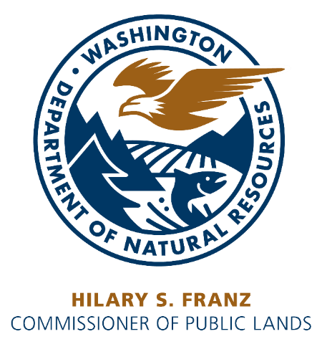

APPLICATION FOR A MINERAL PROSPECTING LEASE ON STATE UPLANDS
(Do not use this form to apply for a Mineral Prospecting Lease on State-owned Aquatic Lands)

APPLICATION FOR: Upland Mineral Prospecting Lease (check the appropriate boxes to indicate the minerals sought).

___ Metallic minerals ___ Industrial minerals (please identify: )

___ Crystal and mineral specimens, gemstones ___ Fossils

Applications will be considered in the order received by the Department of Natural Resources (DNR). All applications for metallic and industrial minerals will be considered and decisions made based on the asset management criteria listed on the reverse side of this application. In addition, an administrative review will determine the potential impacts and benefits of the proposed lease. Documentation provided by the applicant, with the application, will be the sole source of information used to determine if the applicant meets the stated criteria. Applications submitted without sufficient documentation for meeting the asset management criteria or without the required topographic map or aerial photo will be rejected. Rejected applications will be returned to the applicant and will receive no further consideration.

Liability insurance and a performance security are required upon the signing of any lease.

Please send 2 copies of this application and the $25.00 application fee to:

Department of Natural Resources
Product Sales & Leasing Division
PO Box 47014
Olympia, WA 98504-7016

Please provide a full legal description of the property for which the application is being made. The maximum acreage per application is 640 acres or one government section. A lease may include land parcels in several sections within a single township and range, but it cannot exceed 640 acres.

Section(s) ____ Township(s) ______, Range(s) ____ (East/West), containing _____acres, in _______________ County

A topographic map or aerial photo at a scale of 1:24,000 (7½ minute quadrangle), or a more detailed map showing at a minimum the outline of the area applied for and the access roads to be used, must accompany this application.

Dated at , Washington, this day of , 20 .

Signature Contact person

Print Name_____________________________ Print Name _____________________________
Title Company

Address Address

Zip+4 Zip+4

Telephone No. ( ) Telephone No. ( )

UBI # FAX No. ( )

FOR DEPARTMENT USE ONLY

Amts. Rec'd: $________________ App Fee: $_______________ Date _________________

Application No. 65-____________ Trust ____________ Agency ______________________

State Trust Lands Asset Management

Washington's Department of Natural Resources (DNR) manages about 5.6 million acres of state-owned lands for long-term economic, ecological and other public benefits. These lands include 2.6 million acres of aquatic lands (mostly submerged marine lands), and about 3 million acres of trust lands, most of which were granted by Congress to Washington at statehood in 1889. In addition, 130,000 acres are natural areas that protect native ecosystem and wildlife species and offer opportunities for study and light recreation, where appropriate.

Of the state trust lands, 2.1 million acres are forest lands, 1.2 million acres agricultural and range lands (about 300,000 of these acres are both forest and range lands), and 26,000 acres of commercial properties. DNR has the responsibility to generate revenue for specific beneficiaries—the state’s public schools and universities and other specific trust beneficiaries.

Asset Management Criteria for Issuing New Mineral Prospecting Leases

Mineral Prospecting Leases are issued with the anticipation that if exploration conducted on the lease area is successful, substantial royalty income from mining may be returned to the beneficiaries of the specific trust parcels. The greatest financial benefits from mineral prospecting leasing comes from royalties paid when the minerals are mined. The highest financial return to the trust beneficiaries results from leases issued to applicants who have the experience and the financial capability to fully explore and develop the property to production, if the site warrants such action.

Lease Application

All applications for mineral prospecting leases will consider the ability of the applicant to meet the following criteria. All supporting documentation must be provided with the application to lease or the application will be rejected and returned without further consideration. Applications for placer mining contracts do not need to include the following information.

All successful applicants will be required to provide proof of the required liability insurance, and a performance security upon the signing of the lease.

Experience

Applicant must demonstrate at least one of the following:

Education

Documentation of the equivalent of two years of post-high-school education in earth science, geology, mining, or other related field from an accredited institution of higher learning.

Mineral Exploration Experience

Documentation of the equivalent of two years’ experience in the exploration for potential, commercially viable metallic mineral, industrial mineral, or aggregate properties.

Mining Experience

Documentation of the equivalent of two years’ experience in mining engineering, mining, or mine/property development of a commercially viable mining property.

Financial Capability

Applicant must demonstrate at least one of the following:

- Documentation of the ability to conduct and fund initial exploration to determine the potential of a mineral prospect.

- Documentation of the ability to obtain capital for mineral exploration and/or development of a commercially viable mineral prospect.

- Documentation of ability to joint venture or contract with others who have the ability to obtain or provide capital for mineral exploration and/or development of a property leading to production of a commercially viable mining property.

Authorization to do Business in the State of Washington

All applicants, except those applying as an individual(s), must be authorized to do business in the state of Washington. A valid UBI number from the Washington State Department of Revenue is required on the application from all businesses. This includes corporations or other businesses that are licensed to do business in other states or counties.

Mining Contract

If a site proves fruitful, a mining contract is required before minerals can be mined. Applications to convert a Mineral Prospecting Lease to a Mining Contract can be submitted anytime, up to 180 days before the end of the seven (7) year lease period. The lease will be converted to a Mining Contract if the lessee can satisfy the conversion requirements of the Department.

Mineral Prospecting Lease Not Converted to a Mining Contract for Application Area

Any lessee, their agents, or associates, not converting a Mineral Prospecting Lease to a mining contract cannot apply for nor receive a new Mineral Prospecting Lease that includes the same lease area for one year from the expiration date of the prior lease.

FOR MORE INFORMATION PLEASE CONTACT

Product Sales & Leasing Division in Olympia at (360) 902-1600.

