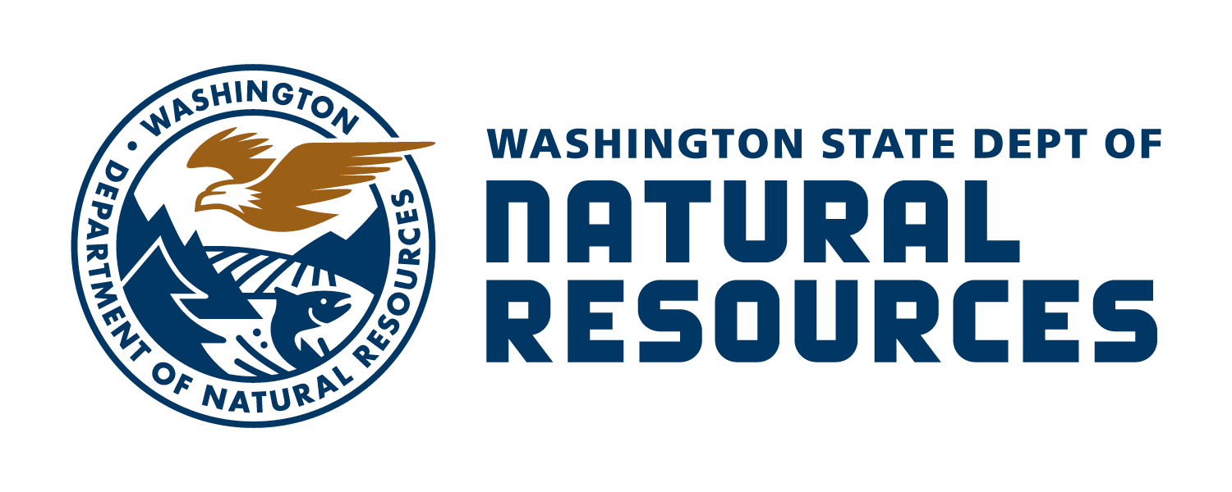
OIL & GAS
BLANKET DRILLING AND PRODUCTION BOND

Bond No.
KNOW ALL PEOPLE BY THESE PRESENTS, That we, name of principal, as Principal, and name of surety, organized and existing under the laws of the State of state in which surety organized and authorized to transact business in the State of Washington as Surety, are held and firmly bound unto the State of Washington, acting through the Department of Natural Resources, in the sum of ($ ) U.S. DOLLARS, for the payment of which sum we bind ourselves and each of our legal representatives, heirs, executors, administrators, successors, and assigns, jointly and severally, firmly by these presents.

name of principal, Principal has made and/or will make applications for permits to drill for gas and/or oil under RCW 78.52 and WAC 344.12, which are enforced by the Washington State Department of Natural Resources (DNR). The Principal may also hold permits acquired through transfer pursuant to WAC 344-12-055. A list of currently identifiable sites and well locations is attached hereto as Exhibit A. As a statewide blanket bond under WAC 344-12-060, this bond covers all of the Principal’s current and future permitted oil and gas permits and the associated wells and related operations regulated by DNR. The surety’s failure to know, currently or in the future, of Principal’s oil and gas permits and their associated wells and related operations regulated by DNR does not prevent the applicability of this bond to said permits, wells, or operations.

THE PRINCIPAL desires to give this bond as required by RCW 78.52 and WAC 344-12. In accordance with RCW 78.52 and WAC 344-12, this bond secures the Principal’s complete performance of all obligations under said oil and gas permits pursuant to RCW 78.52 and WAC 344-12 and the orders, regulations, and permit conditions adopted by the Oil and Gas Conservation Committee and/or DNR.

THIS BOND may be drawn upon by DNR to the extent necessary to bring the well and/or related operations into compliance with RCW 78.52, WAC 344-12, and the orders, regulations, and permit conditions adopted by the Oil and Gas Conservation Committee and/or DNR, as determined by DNR.

NOW THEREFORE if said Principal fully complies with all of its permits, RCW 78.52, WAC 344-12, and the orders, regulations, and permit conditions adopted by the Oil and Gas Conservation Committee and/or DNR governing oil and/or gas drilling, production, and operations AND if the Principal procures from the Oil and Gas Supervisor his approval for abandonment of each well drilled by the Principal, then the above obligations shall be void; otherwise, they shall remain in full force and effect.

PROVIDED THAT the total liability of the surety hereunder for all causes of action arising under this bond shall not exceed the total sum of ($ ) U.S. DOLLARS.

IN WITNESS whereof the said Principal has hereunder set his hand and seal, and the surety caused these presents to be signed by its duly authorized officers and its corporate seal to be hereto affixed this ____ day of _____________.

Attorney in fact (type name below line) |  | Principal (type name below line)
Attorney name Principal name
Surety name Principal title
Mailing address Company name
City, State, Zip Mailing address
Phone number City, State, Zip
Email address Phone number
Name of local agent, if applicable Phone number Email address
Address of local agent
Approved as to form this day day of month, year
Assistant Attorney General
OIL & GAS BLANKET
DRILLING AND PRODUCTION BOND
Exhibit A
Bond no. Issue date
Drill site name Drill site location
Drill site name Drill site location
Drill site name Drill site location
Drill site name Drill site location
Drill site name Drill site location
Drill site name Drill site location
Drill site name Drill site location
Drill site name Drill site location
Drill site name Drill site location
Drill site name Drill site location
Drill site name Drill site location
Drill site name Drill site location
Drill site name Drill site location
Drill site name Drill site location
Drill site name Drill site location
Drill site name Drill site location
Drill site name Drill site location
Drill site name Drill site location
Drill site name Drill site location
Drill site name Drill site location
Drill site name Drill site location
Drill site name Drill site location
Drill site name Drill site location
Drill site name Drill site location
Drill site name Drill site location
Drill site name Drill site location

